**Date: 04/06/2024**

**1.BINARY TO DECIMAL CONVERSION**

|  |  |  |  |  |  |  |  |  |
| --- | --- | --- | --- | --- | --- | --- | --- | --- |
| 1 | 0 | 0 | 1 | 0 | 0 | 1 | 0 | 146 |
| 0 | 1 | 1 | 1 | 0 | 1 | 1 | 1 | 119 |
| 1 | 1 | 1 | 1 | 1 | 1 | 1 | 1 | 255 |
| 1 | 1 | 0 | 0 | 0 | 1 | 1 | 1 | 197 |
| 1 | 1 | 1 | 1 | 0 | 1 | 1 | 0 | 246 |
| 0 | 0 | 0 | 1 | 0 | 0 | 0 | 1 | 19 |
| 1 | 0 | 0 | 0 | 0 | 0 | 0 | 0 | 129 |
| 0 | 0 | 1 | 1 | 0 | 0 | 0 | 1 | 49 |
| 0 | 1 | 1 | 1 | 1 | 0 | 0 | 0 | 120 |
| 1 | 1 | 1 | 1 | 0 | 0 | 0 | 0 | 240 |
| 0 | 0 | 1 | 1 | 1 | 0 | 1 | 1 | 59 |
| 0 | 0 | 0 | 0 | 0 | 1 | 1 | 1 | 7 |
| 0 | 0 | 0 | 1 | 1 | 0 | 1 | 1 | 27 |
| 1 | 0 | 1 | 0 | 1 | 0 | 1 | 0 | 170 |

**2.ADDRESS CLASS IDENTIFICATION**

RULES

**A->1-126**

**B->128-191**

**C->192-223**

**D->224-239**

10.250.1.1 ----------------------------🡪A

150.10.15.0 ----------------------------🡪B

192.14.2.0 ----------------------------🡪C

148.17.9.1 ----------------------------🡪B

193.42.1.1 ----------------------------🡪C

126.8.156.0 ----------------------------🡪B

230.230.45.58 ----------------------------🡪D

177.100.18.4 ----------------------------🡪B

119.18.45.0 ----------------------------🡪B

249.240.80.78 ----------------------------🡪E

**3.NETWORK HOST IDENTIFICATION**

**A->1-127**

**B->128-191 AN H H H**

**C->192-223 B->N N H H**

**D->224-239 C-> N N N H**

|  |  |  |
| --- | --- | --- |
| IP ADRESS | NETWORK | HOST |
| 177.100.18.4 | 177.100 | 18.4 |
| 119.18.45.0 | 119 | 18.45.0 |
| 209.240.80.78 | 209.240.80 | 78 |
| 199.155.77.56 | 199.155 | 77.56 |
| 117.89.56.45 | 117 | 89.56.45 |
| 215.45.45.0 | 215.45.45 | 0 |
| 192.200.15.0 | 192.200.15 | 0 |
| 95.0.21.90 | 95 | 0.21.90 |
| 33.0.0.0 | 33 | 0.0.0 |
| 158.98.80.0 | 158.98 | 80.0 |
| 217.21.56.0 | 217.21.56 | 0 |
| 10.250.1.1 | 10 | 250.1.1 |

**4.DECIMAL TO BINARY**

|  |  |  |  |  |  |  |  |  |
| --- | --- | --- | --- | --- | --- | --- | --- | --- |
| DECIMAL | 128 | 64 | 32 | 16 | 8 | 4 | 2 | 1 |
| 238 | 1 | 1 | 1 | 0 | 1 | 1 | 1 | 0 |
| 34 | 0 | 0 | 1 | 0 | 0 | 0 | 1 | 0 |
| 123 | 0 | 1 | 1 | 1 | 1 | 0 | 1 | 1 |
| 50 | 0 | 0 | 1 | 1 | 0 | 0 | 1 | 0 |
| 255 | 1 | 1 | 1 | 1 | 1 | 1 | 1 | 1 |
| 200 | 1 | 1 | 0 | 0 | 1 | 0 | 0 | 0 |
| 10 | 0 | 0 | 0 | 0 | 1 | 0 | 1 | 0 |
| 138 | 1 | 0 | 0 | 0 | 1 | 0 | 1 | 0 |
| 1 | 0 | 0 | 0 | 0 | 0 | 0 | 0 | 1 |
| 13 | 0 | 0 | 0 | 0 | 1 | 1 | 0 | 1 |
| 250 | 1 | 1 | 1 | 1 | 1 | 0 | 1 | 0 |
| 107 | 0 | 1 | 1 | 0 | 1 | 0 | 1 | 1 |
| 227 | 0 | 1 | 1 | 1 | 1 | 1 | 1 | 1 |
| 114 | 0 | 1 | 1 | 1 | 0 | 0 | 1 | 0 |
| 192 | 1 | 1 | 0 | 0 | 0 | 0 | 0 | 0 |

**Date:05/06/2024**

**5.DEFAULT SUBNET MARKS**

**A->1-127**

**B->128-191 A250.0.0.0**

**C->192-223 B->255.255.0.0.**

**D->224-239 C-> 255.255.255.0**

|  |  |
| --- | --- |
| 177.100.18.4 | 255.255.0.0 |
| 119.18.45.0 | 255.0.0.0 |
| 191.249.234.109 | 255.255.0.0 |
| 10.10.250.1 | 255.0.0.0 |
| 126.123.23.1 | 255.0.0.0 |
| 223.69.230.250 | 255.255.255.0 |
| 192.12.35.105 | 255.255.255.0 |
| 77.251.200.51 | 255.0.0.0 |
| 189.210.50.1 | 225.255.0.0 |
| 88.45.65.35 | 255.0.0.0 |
| 128.212.250.254 | 255.255.0.0 |

**6.NETWORK ADDRESS**

|  |  |
| --- | --- |
| 188.10.18.2  255.255.0.0 | 188.10.0.0 |
| 10.10.48.80  255.255.255.0 | 10.10.48.0 |
| 192.149.24.191  255.255.255.0 | 192.149.24.0 |
| 150.203.23.19  255.255.0.0 | 150.203.0.0 |
| 10.10.10.10  255.0.0.0 | 10.0.0.0 |
| 186.13.23.110  255.255.255.0 | 186.13.23.0 |
| 223.69.230.250  255.255.0.0 | 223.69.0.0 |
| 200.120.135.15  255.255.255.0 | 200.120.135.0 |
| 223.169.23.20  255.255.255.0 | 223.169.23.0 |

**7. HOST ADDRESS**

|  |  |
| --- | --- |
| 188.10.18.2  255.255.0.0 | 0.0.18.2 |
| 10.10.48.80  255.255.255.0 | 0.0.0.80 |
| 222.49.49.11  255.255.255.0 | 0.0.0.11 |
| 128.23.230.19  255.255.0.0 | 0.0.230.19 |
| 10.10.10.10  255.0.0.0 | 0.10.10.10 |
| 200.113.123.11  255.255.255.0 | 0.0.0.11 |
| 223.169.23.20  255.255.0.0 | 0.0.23.20 |

**8.BROADCAST ADDRESS ADDRESS**

|  |  |
| --- | --- |
| 188.10.18.2  255.255.0.0 | 188.10.255.255 |
| 10.10.48.80  255.255.255.0 | 10.10.48.255 |
| 192.149.24.191  255.255.255.0 | 192.149.24.255 |
| 150.203.23.19  255.255.0.0 | 150.203.255.255 |
| 10.10.10.10  255.0.0.0 | 10.255.255.255 |
| 186.13.23.110  255.255.255.0 | 186.13.23.255 |
| 223.69.230.250  255.255.0.0 | 223.69.255.255 |
| 200.120.135.15  255.255.255.0 | 200.120.135.255 |
| 223.169.23.20  255.255.255.0 | 223.169.23.255 |

**9.CUSTOM SUBNET PROBLEM**

Number of needed subnets 🡪6

Number of needed usable hosts 🡪30

Network Address 🡪195.85.8.0

Address class 🡪C

Default subnet mask 🡪255.255.255.0

Custom subnet mask 🡪255.255.255.224

Total number of subnets 🡪8

Total number of host addresses 🡪8

Number of usable addresses 🡪30

Number of bits borrowed 🡪3

**Date:06/06/2024**

Lab1: Connecting the Devices

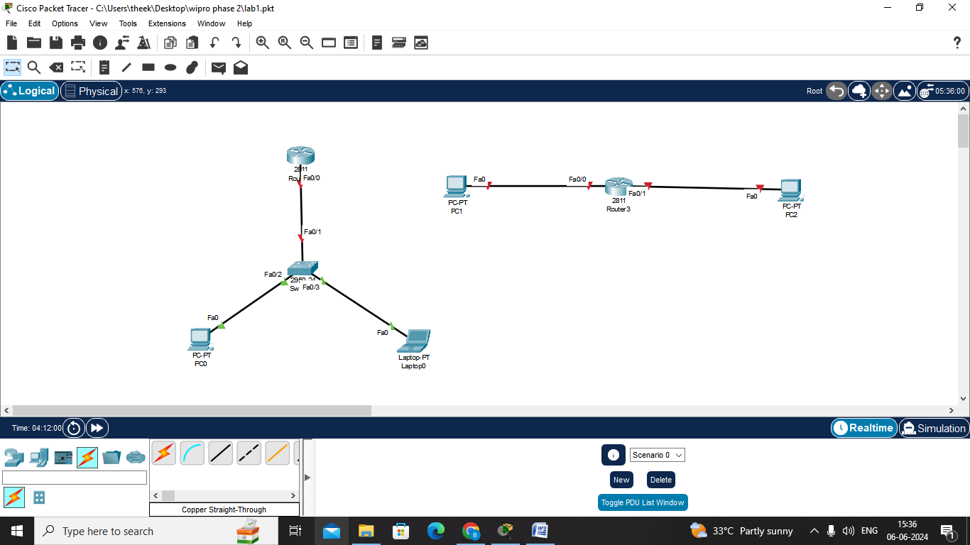

Lab2: IP address Configuration and Ping check

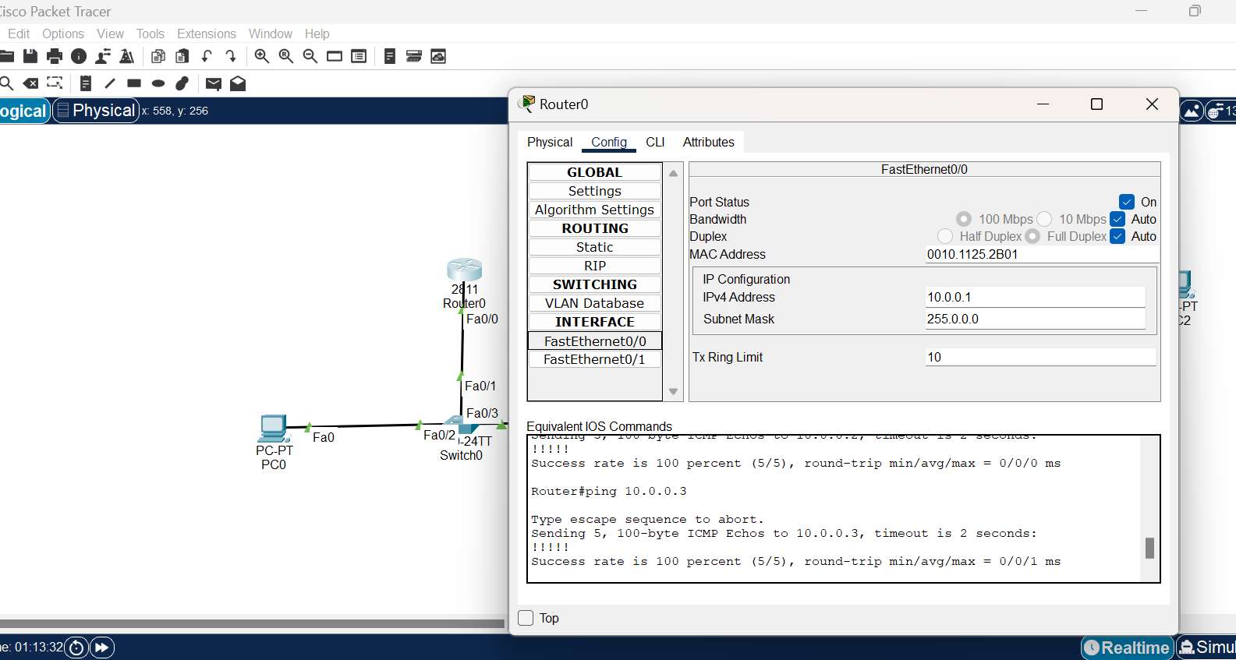

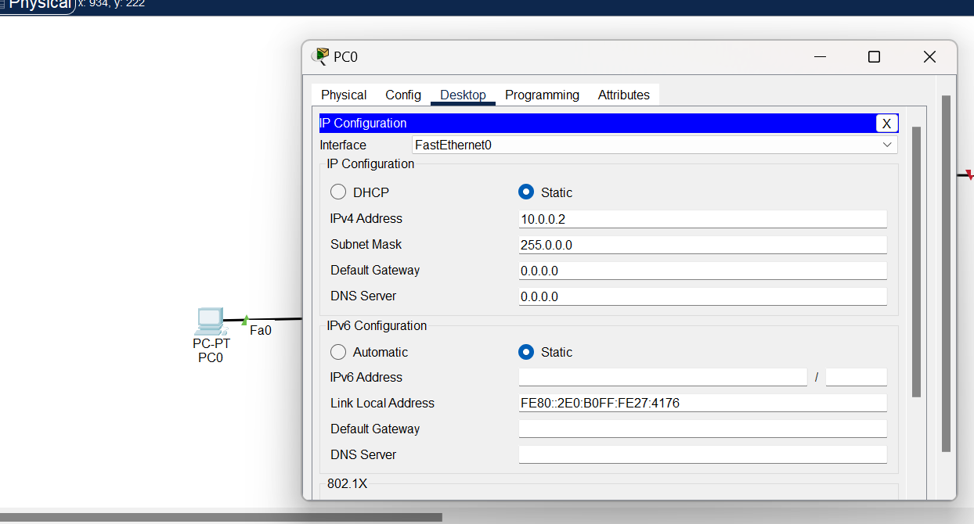

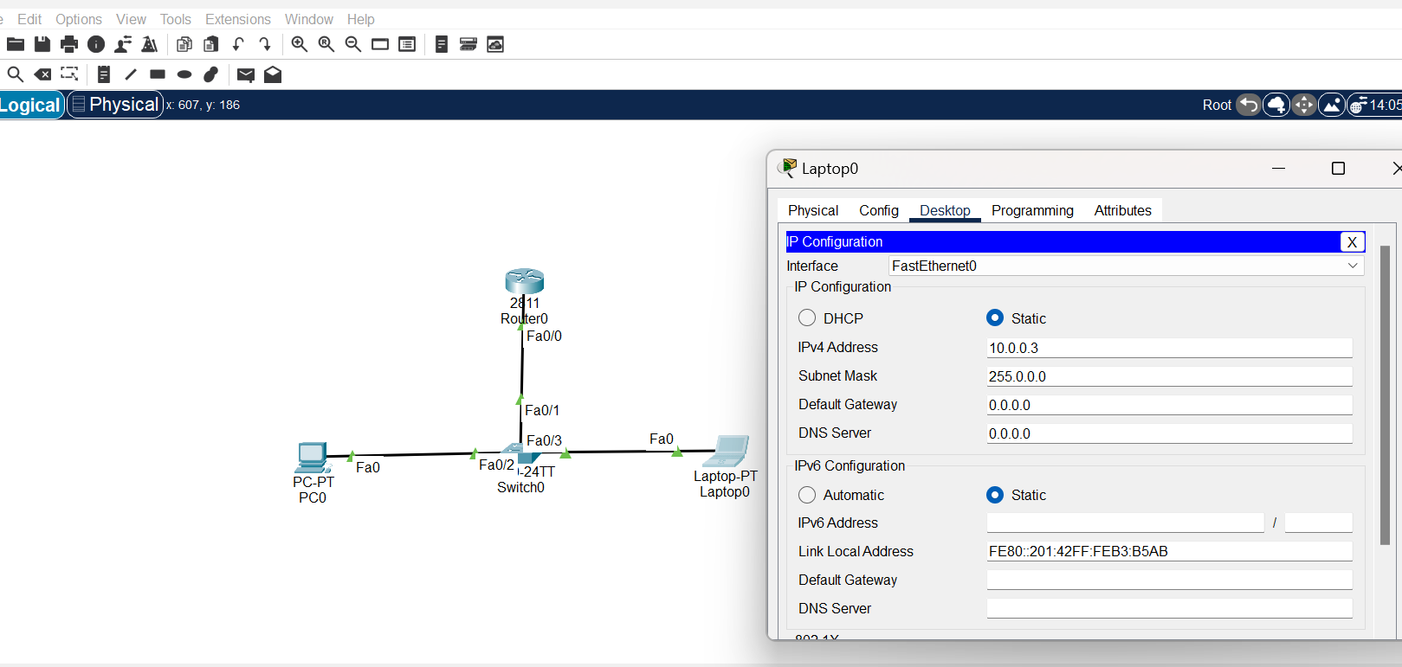

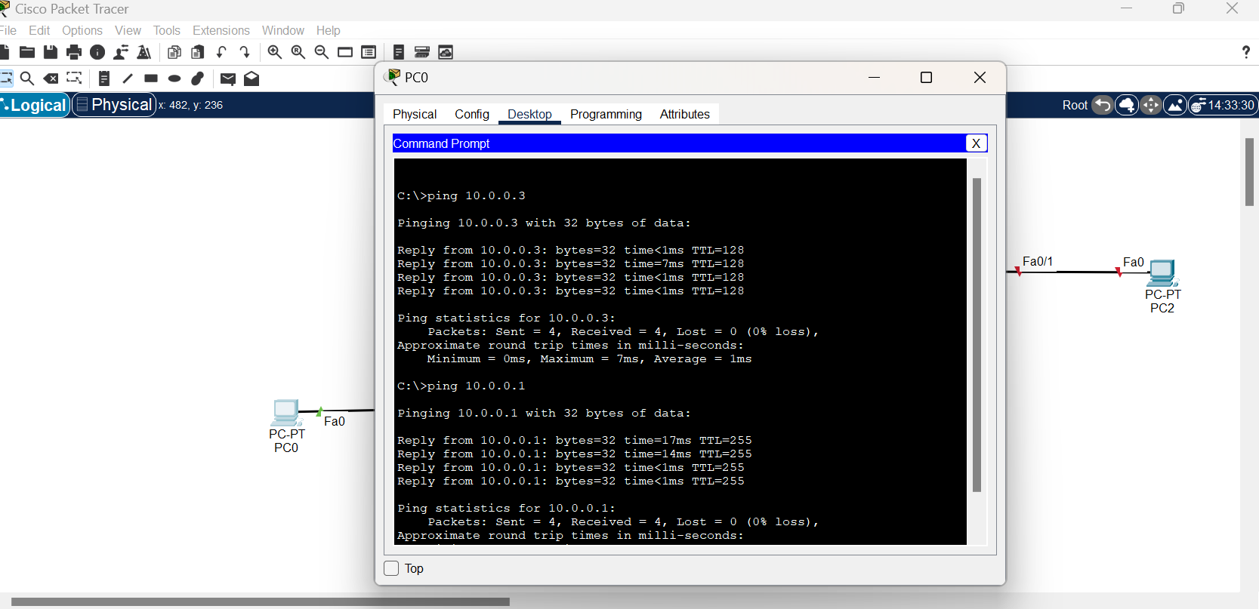

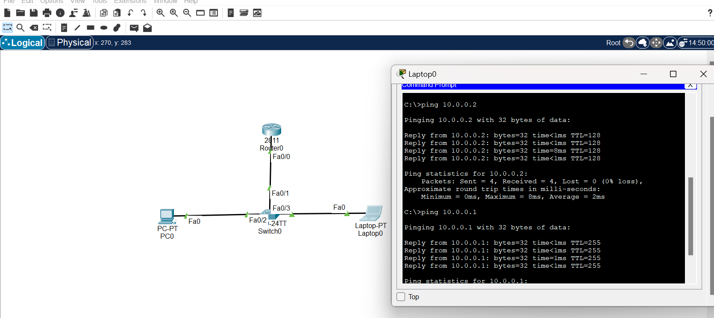

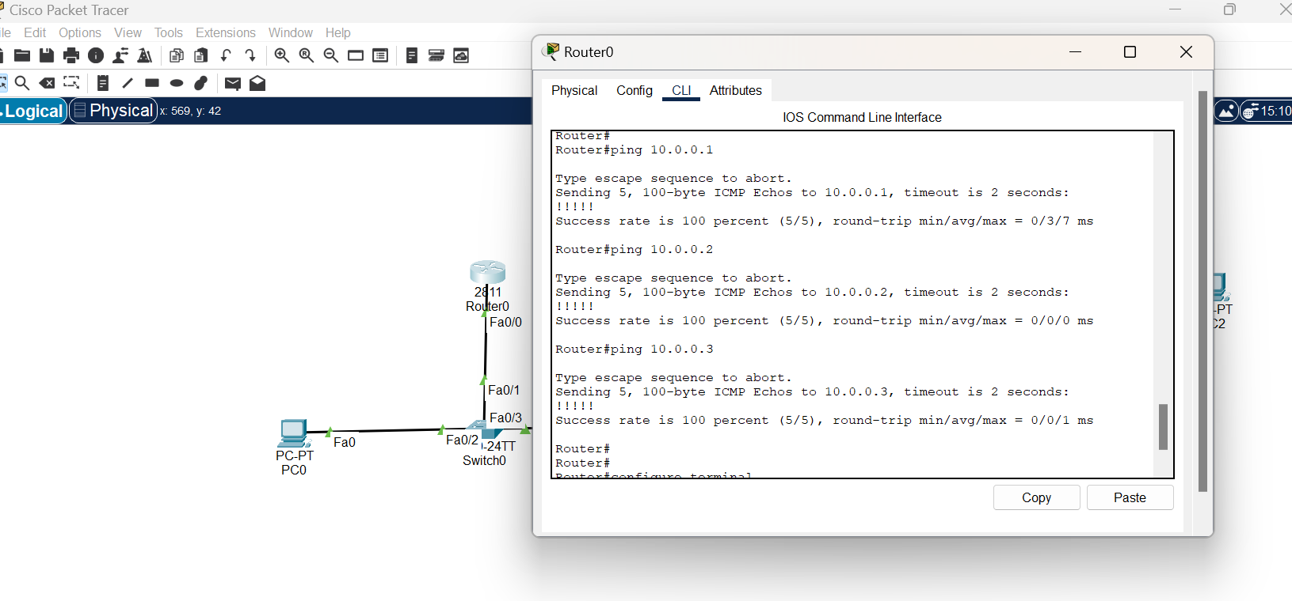

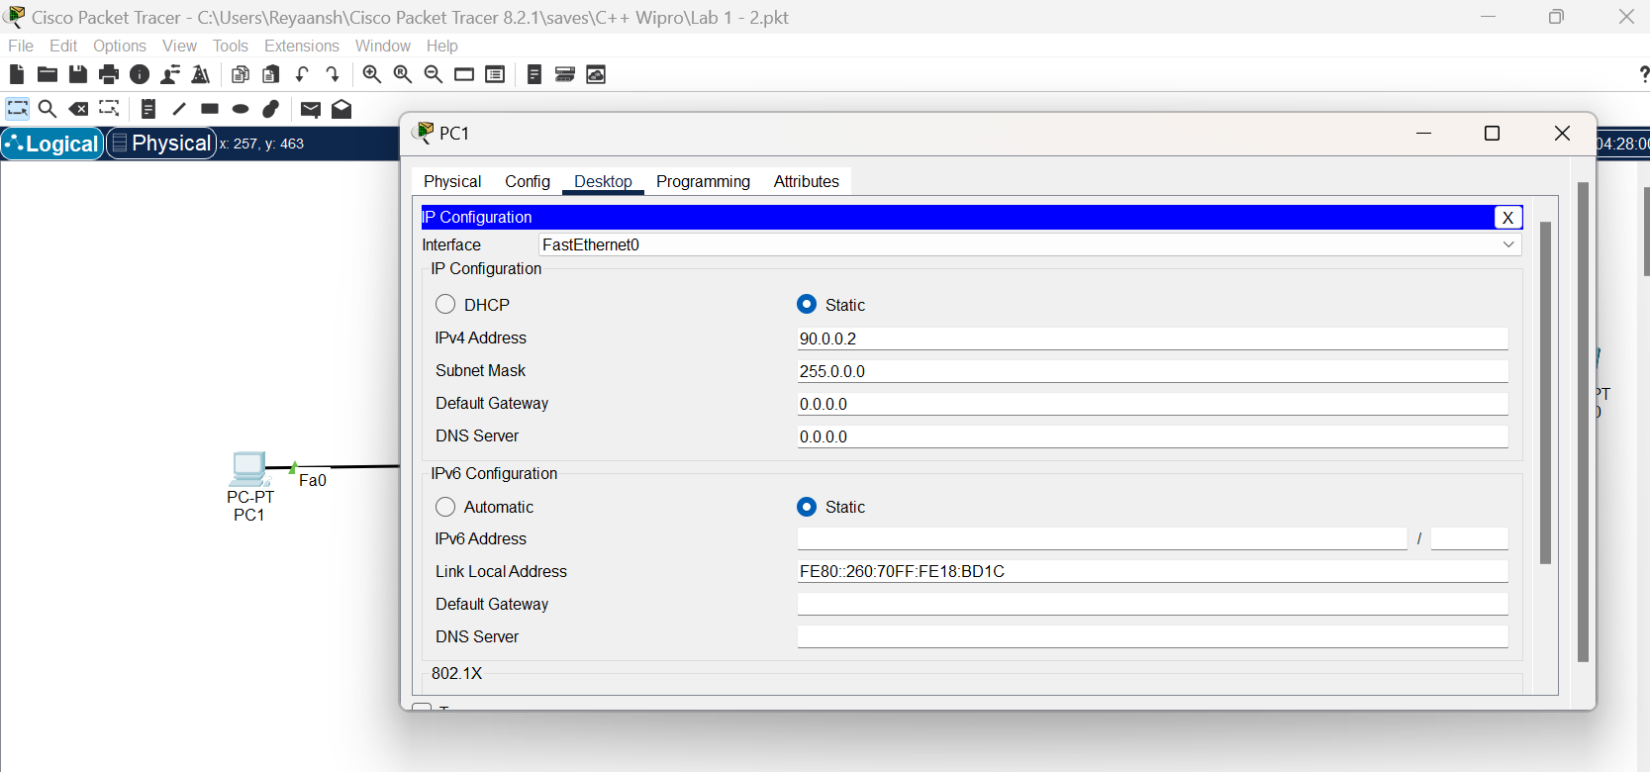

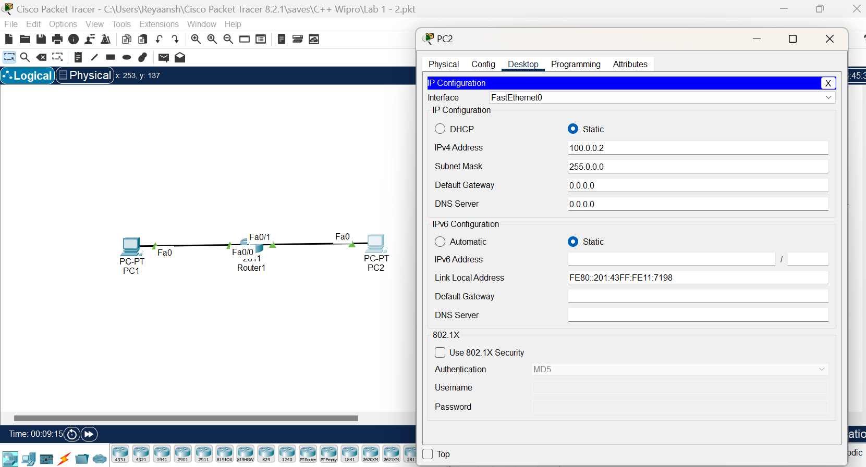

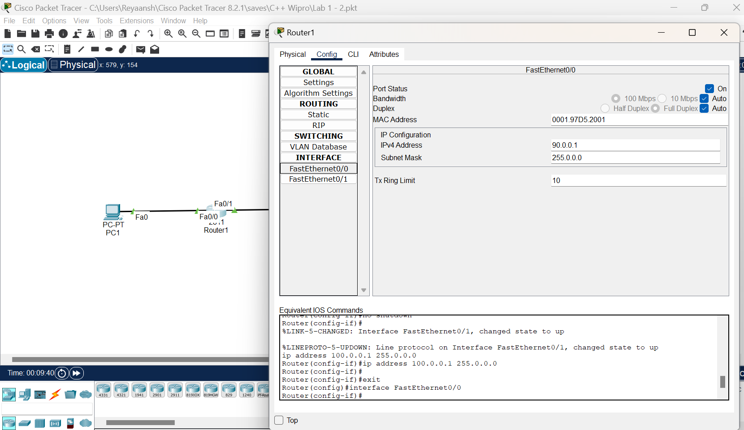



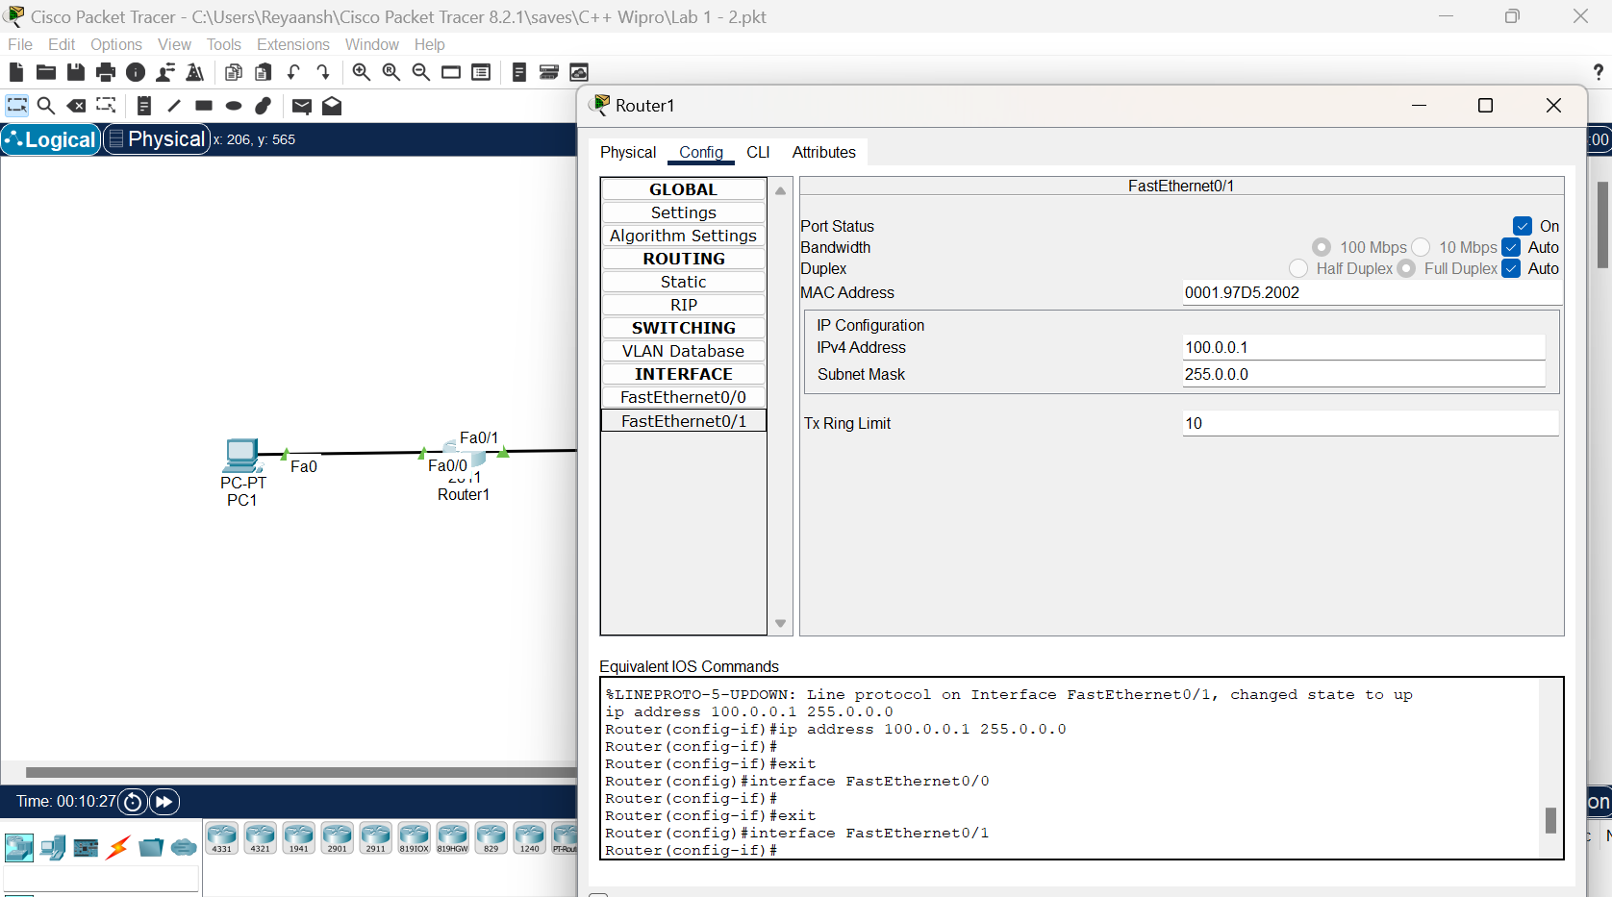

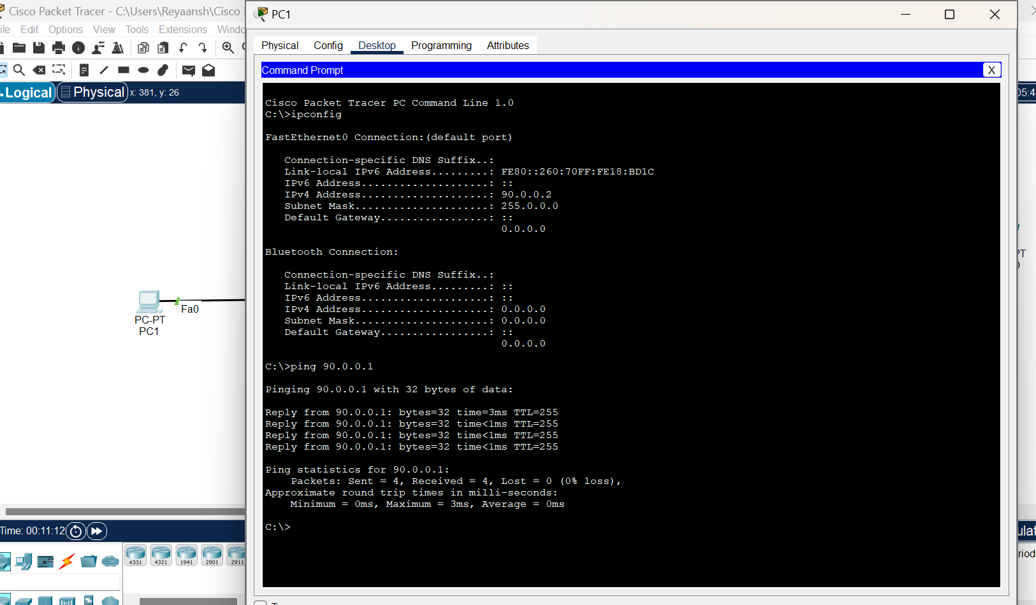

Lab 3: Lab 3: Configuring Default Gateway

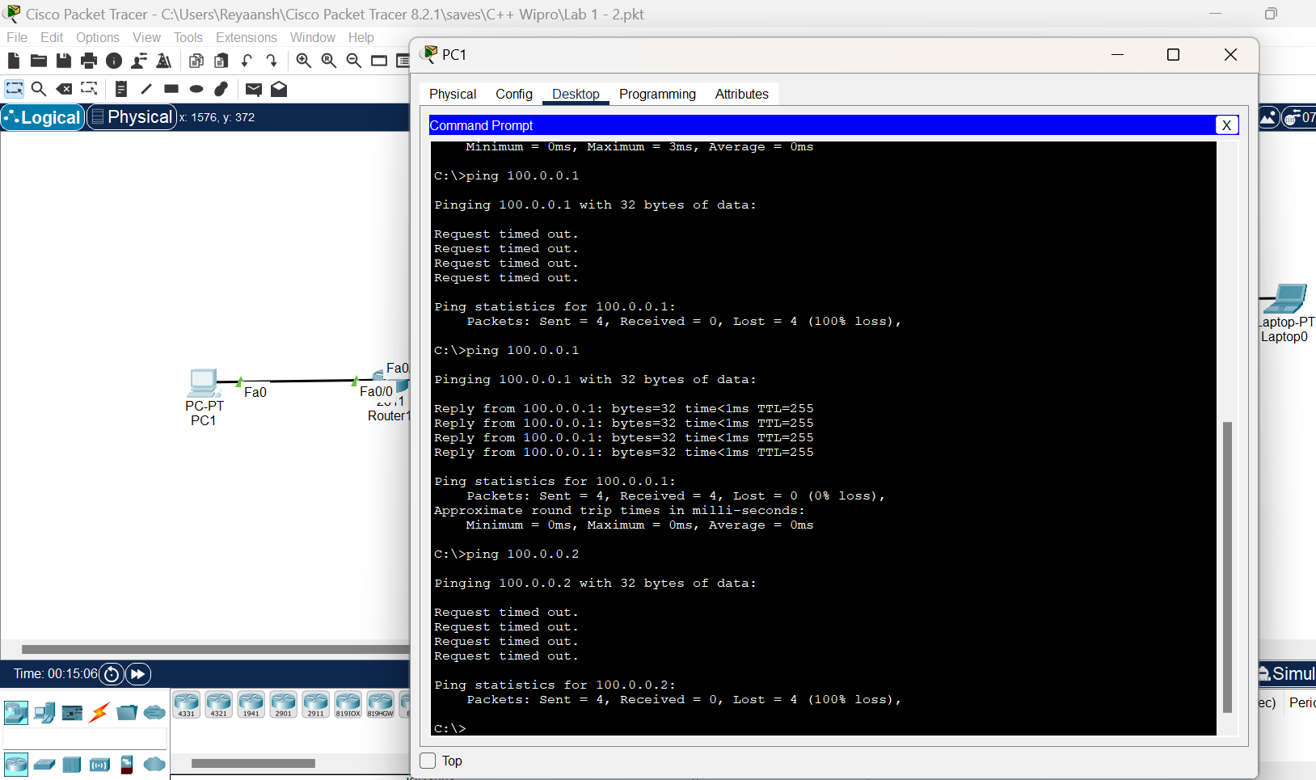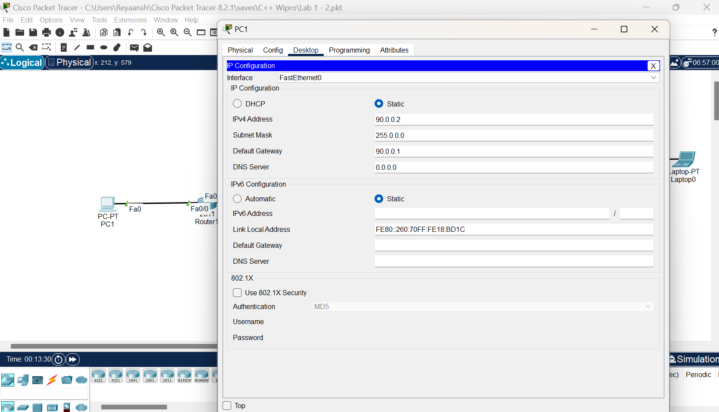

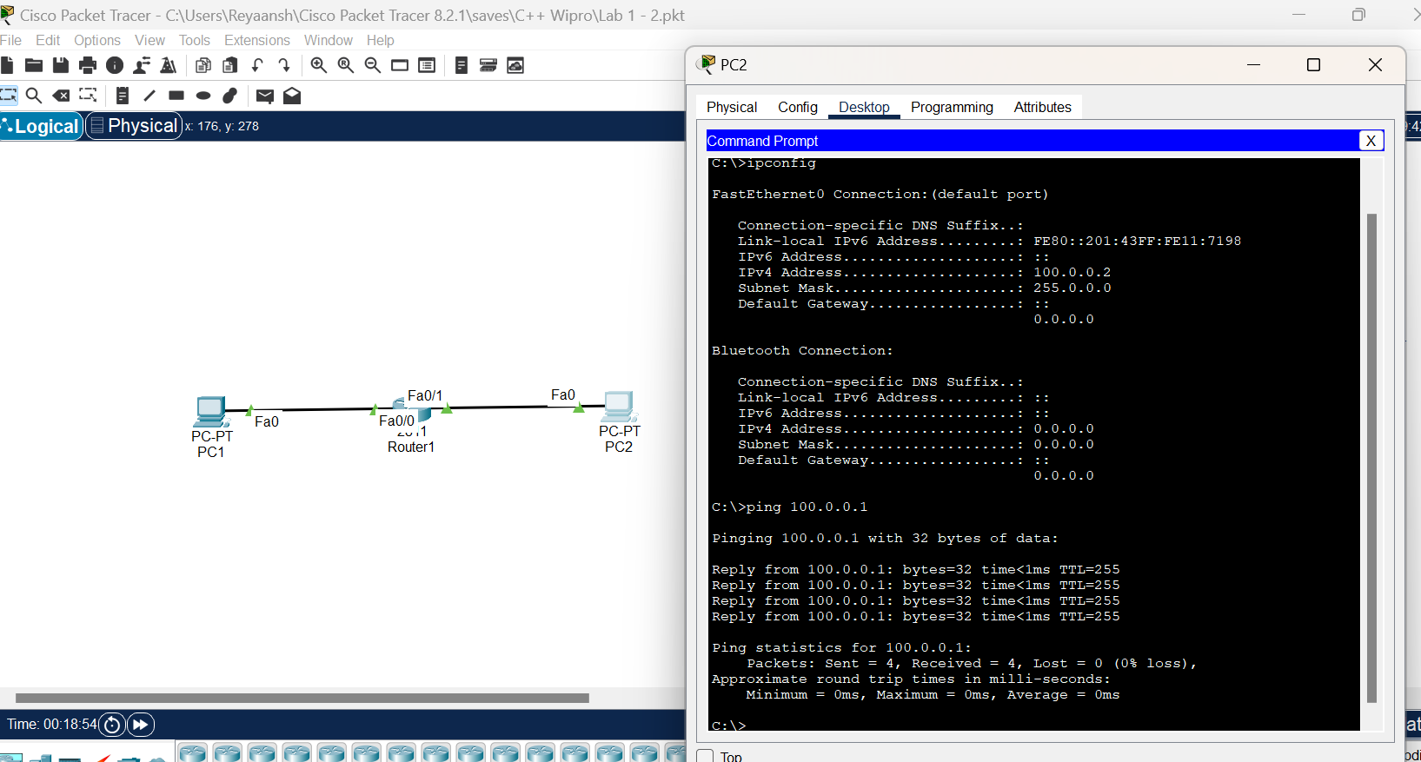

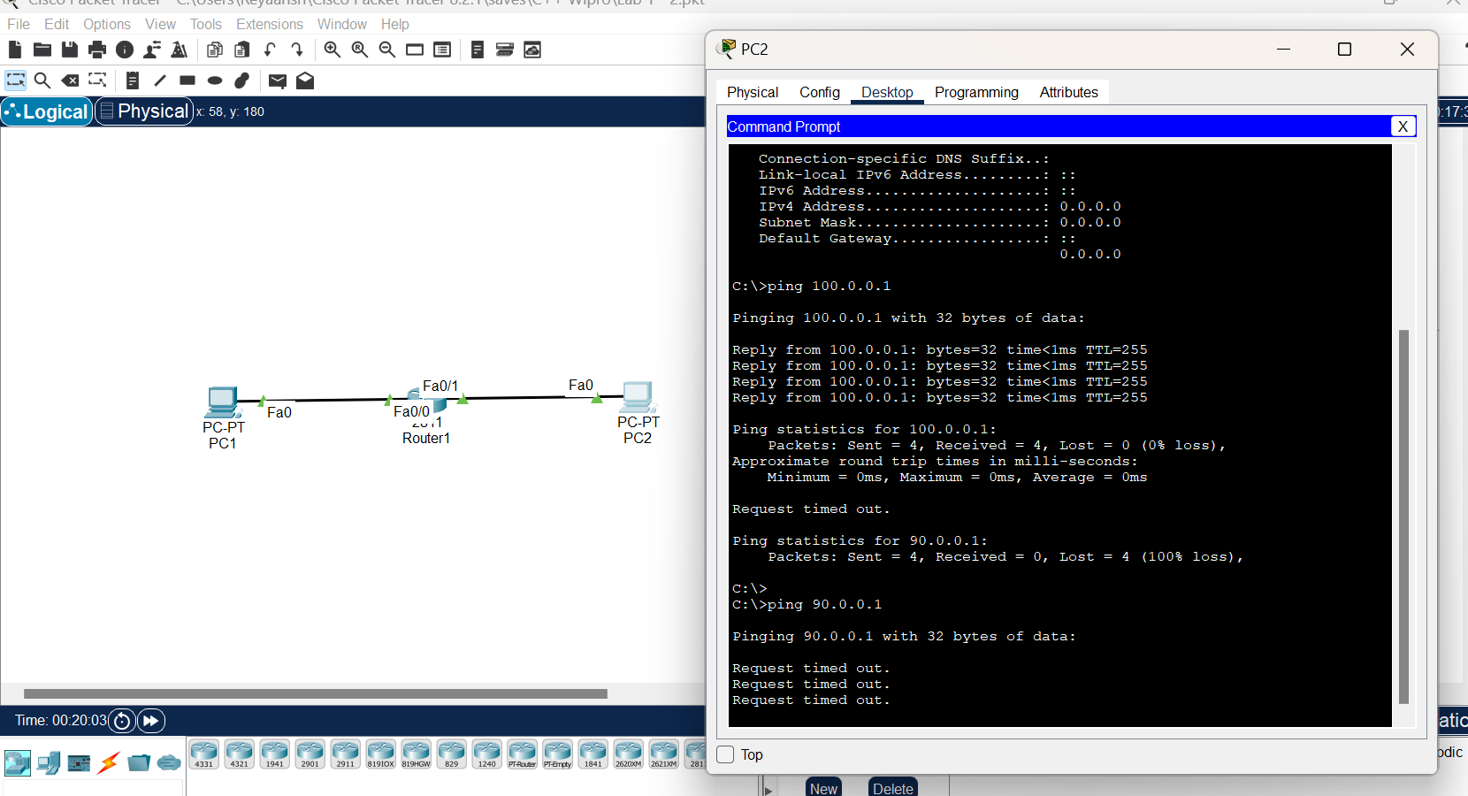



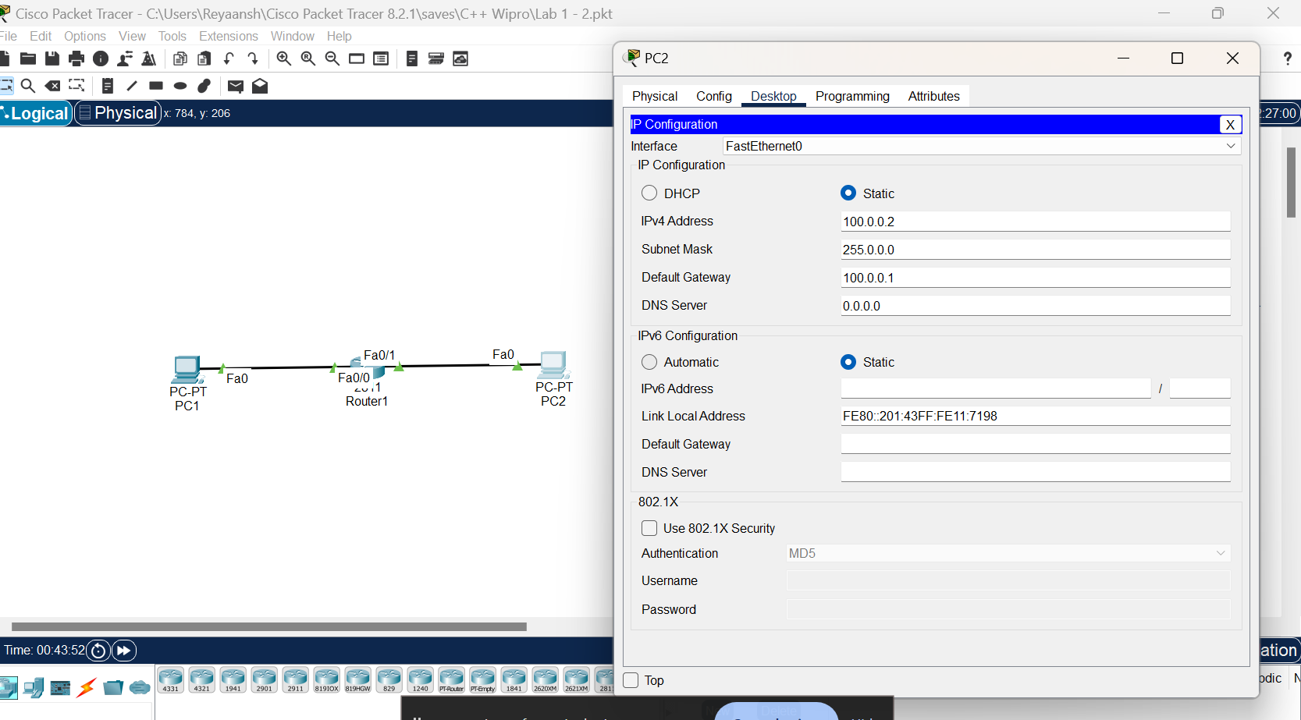

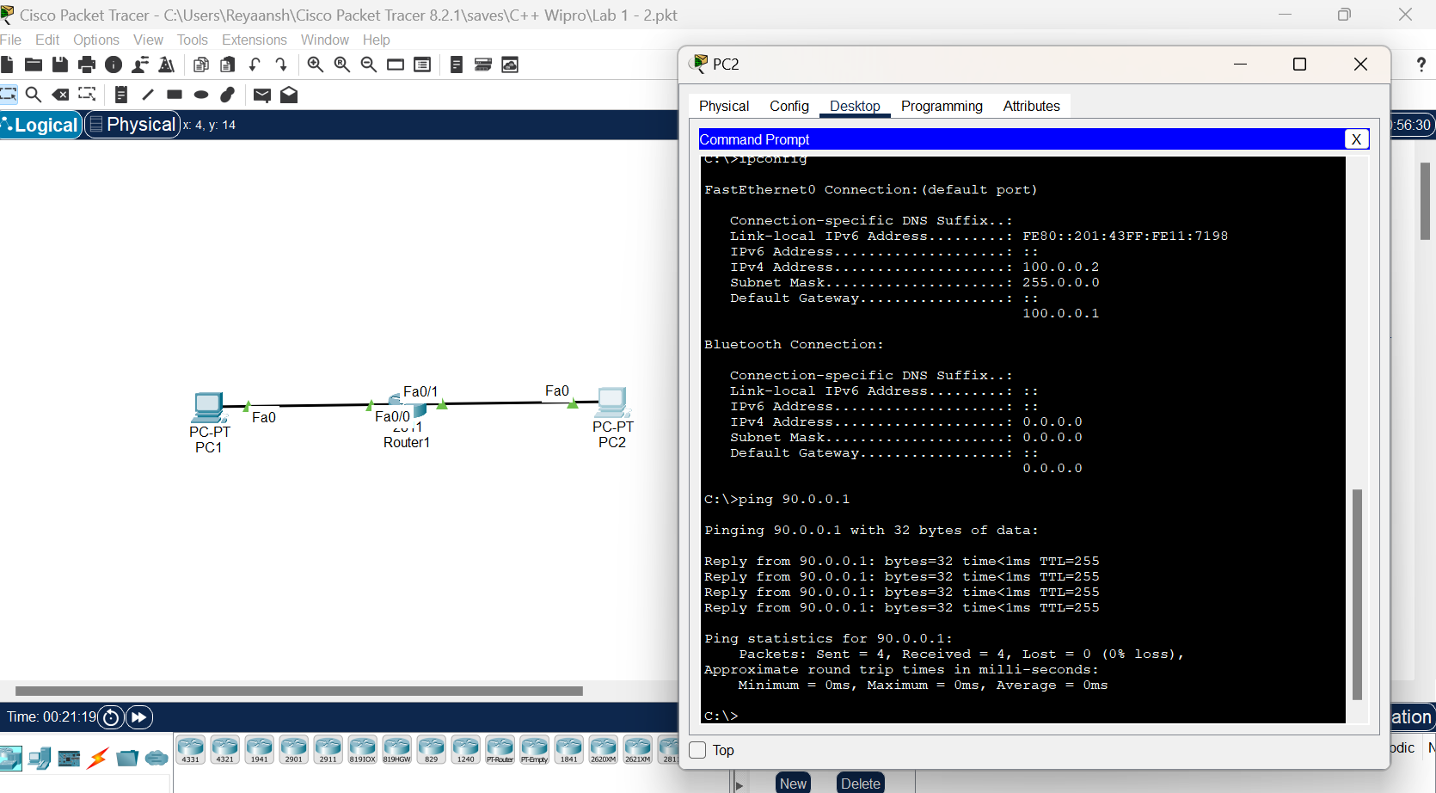

Lab 4 : Static Routing

